

DIGITAL IMAGE PROCESSING ASSIGNMENT 1

SAHANA VENKATESH(USC ID:6643244225)

Table of Contents

1.1Abstraction and Motivation: 1

1.2Approach and Procedures: 2

1.2.1Mirroring an Image, Resizing an Image and Image composition: 2

Mirroring 2

Resizing of an Image 2

1.2.2Colour Transformations: 3

1.2.3 Sepia Filter and Blending Technique: 4

1.3 Experimental Results: 4

Mirroring: 4

Resizing: 5

Image composting: 5

1.4 Discussion 5

Problem 1:

# 1.1Abstraction and Motivation:

When a person uploads his photograph on linked in, resizing happens .Resizing is when up sampling or down sampling is done to increase or decrease the number of pixels in an image.

When a person flips his image on his Iphone along the vertical axis, Mirroring algorithms come into play. When two images are combined into a single one, Image composting comes to play.

Down sampling decreases the number of samples and it is used in many application to store images .Up sampling increases the number of samples in an image. It is important to understand those basic techniques as they are used so much in the real world.

Implementation of these algorithms are discussed in the upcoming section.

The colour space model is way by which you uniquely specifying a colour. Each colour space model is has its applications.

For example Hue, Saturation and Luminance model is how we process/understand colour. CMY is used in printing because intuitively adding more ink should make paper black and it wont be white as in case of RG model. Screens look much brighter when RGB model is used. So, the main point is We try to switch from one colour space to another to make processing easier.

Implementation of how its done is discussed in the upcoming section.

The popular Sepia filter is used to transform Gray Scale images into Colour Images by using simple principles of Matrix multiplication. Other effect which would be discussed is the blending techniques. Two images (they are called layers here) are subjected to manipulations to produce interesting effects on one of the layers.

# 1.2Approach and Procedures:

This section is divided into three parts.

•The Manipulation the physical dimensions and physical properties of the images

to achieve desired result would be subsection 1.

•Idea behind Conversion of one colour space model to another is discussed in

subsection 2.

•The sepia filter and blending techniques are core part of discussion in the sub-

section 3

## 1.2.1Mirroring an Image, Resizing an Image and Image composition:

### Mirroring

is one of the basic operations in Image processing. The key idea is to express the Image as the matrix and flip its columns while leaving its rows undisturbed. The below equation puts the above concept in mathematical form.

Image[Height index][Width index][Bytes Per Pixel]=

Output[Height index][(Width of the image)-Width index][Bytes Per Pixel]-------🡪(1).

### Resizing of an Image

usually involves converting image into smaller or bigger sizes. This is known as sampling. Down sampling is used to reduce the size of the image by dropping pixels along the width and height.

•Ideally we initialise the output image.

•Find a pair of coordinates in the output image.Find the ratio of the Original im-

age size to the output image size .

•Map this ratio to the original image by multiplying this ratio with the co-oridnates

in the output image. We use floor function so that integer indices in the output image is mapped to integer indices in the original image.

ratio=Original Image size /New size;

new index=floor(ratio*(old index)).

Image[Height index][Weight index][BytesPerPixel]=

Original Image[new height index][new width index]

•This is the idea one should have while trying to re size an image to a smaller

size. It is used in web severs to reduce the image size.

Upsampling:

•Ideally we initialise the output image.

•Find a pair of coordinates in the output image. Find the ratio of the Original image size to the output image size .

•Map this ratio to the original image by multiplying this ratio with the cooridnates

in the output image. We use floor and ceil functions so that integer indices in the

output image is mapped to integer indices in the original image.

ratio=Original Image size /New size;

new index=(ratio*(old index)).

### 1.2.2Colour Transformations:

Converting from RGB to CMY and HSL involves normalising R,G,B channels by dividing it by 255.

For CMY model, we need to subtract magnitude of each component of every pixel by

1.(i.e)C=1-R;M=1-G;Y=1-B;You multiply the obtained C,M and Y components by

255 to visualise the corresponding grayscale images.

For HSL, After normalising the R,G and B components, you apply certain formula’s to find Hue, Saturation and Luminance of the pixel as a function of their RGB values.

Hue values lie between 0-360;

Saturation values lie between 0 to 1

and Luminance value lie between 0 to 1.

You multiply the obtained Saturation and luminance components of each pixel by 255 to visualise their corresponding grayscale image. You multiply hue component of each pixel by (255/360) to visualise the corresponding grayscale images.

### 1.2.3 Sepia Filter and Blending Technique:

Sepia filter is used to transform grayscale images as RGB image. We multiply predefined matrix with intensity value of each pixel to get corresponding RGB values.

For Screening ,a blending technique implemented here, you invert all the three colour

components for every pixel in both the layers. Then you multiply pixels of both the

layers(same coordinates) together and invert the product in each component for each pixel and map it to the same coordinates in the output image.

## 1.3 Experimental Results:

## Mirroring:

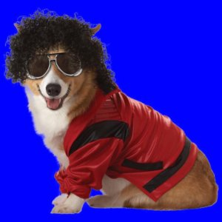 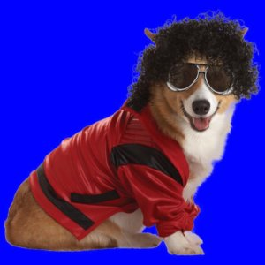

(Fig:1) Original Image (Fig:1.1.a)Mirror Image

## 

## Resizing:

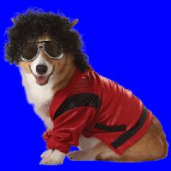 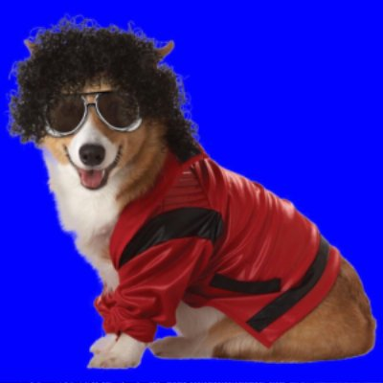 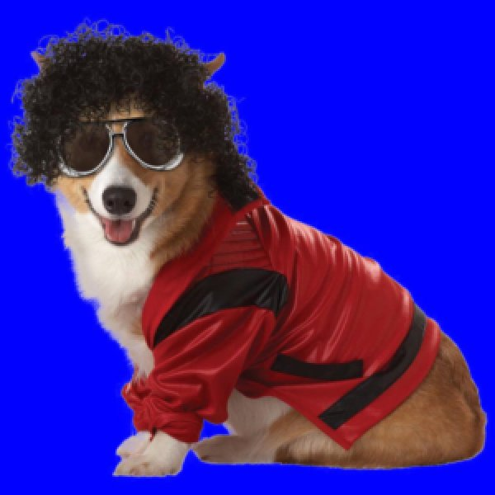

(Fig:1.1.b.1) Size :200*200 (Fig:1.1.b.2) Size :400*400 (Fig:1.1.b.3) Size :600*600

### Image composting:

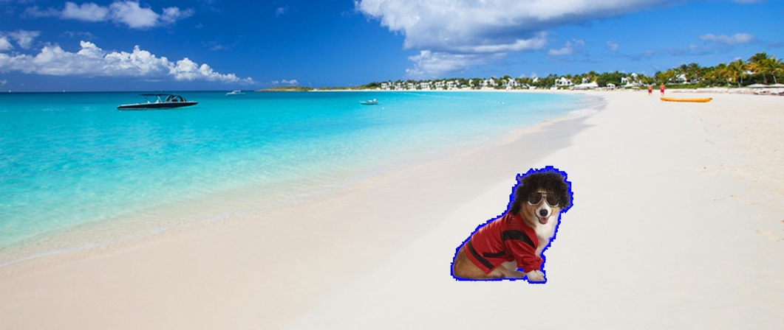

Figure(1.1.c):Image composting

### Colour Space Conversions:

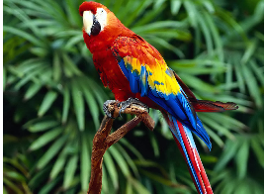

Figure(1.2.a.1) Gray scale image(Cyan)

  

(Yellow Channel) (Magenta Channel (Cyan Channel)

### CMYK CHANNELS FOR THE PARROT

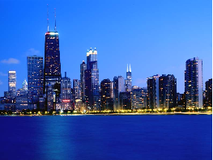

***CMYK CHANNELS FOR THE BUILDING***

 

(Cyan) (Yellow) (Magenta)

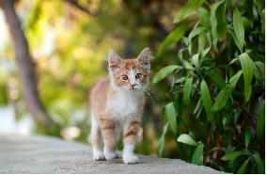

### HSL CHANNELS FOR THE CAT

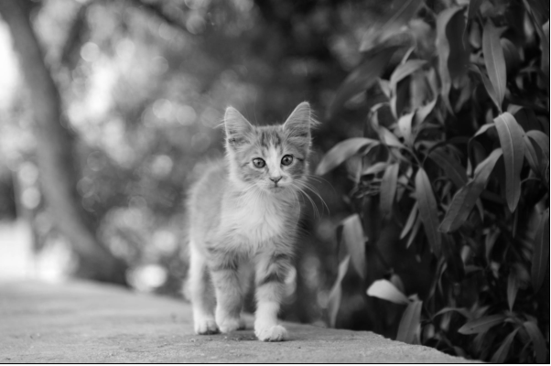 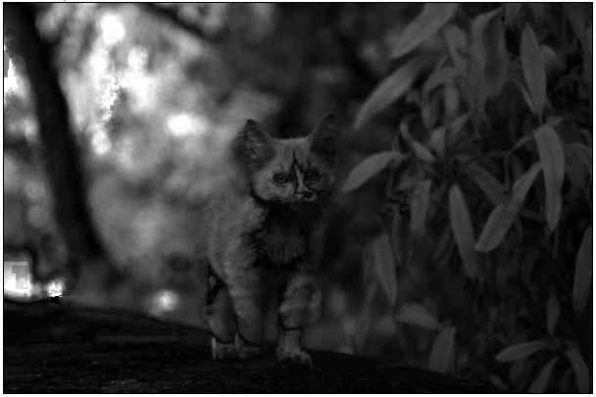

Luminance Saturation

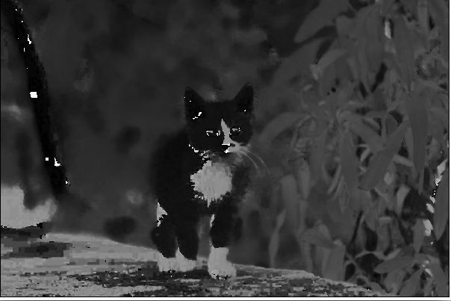

HUE

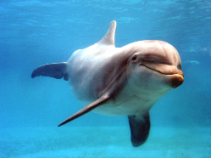

## 

### HSL CHANNELS FOR THE DOLPHINS:

## 

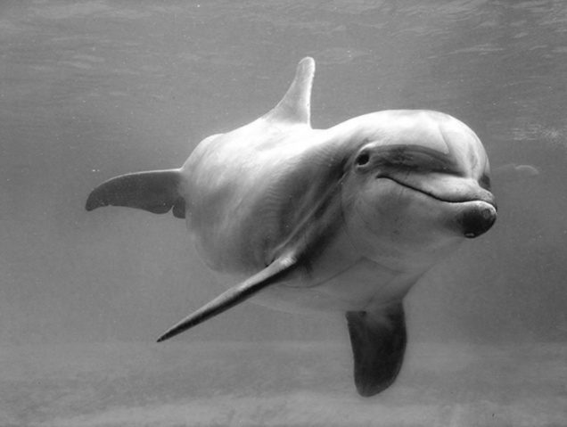 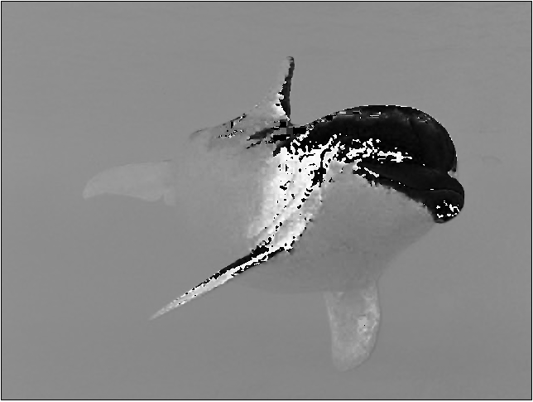

(Luminance) (Hue)

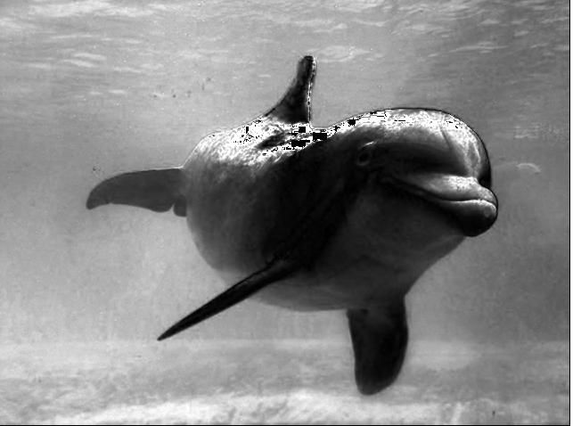

(Saturation)

### Sepia:

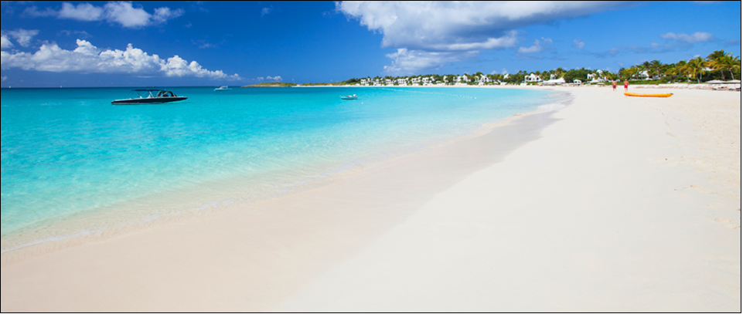

Original image

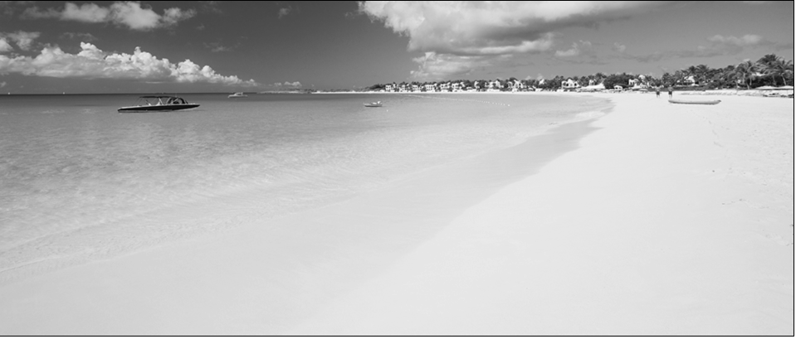

(Intermediate image)

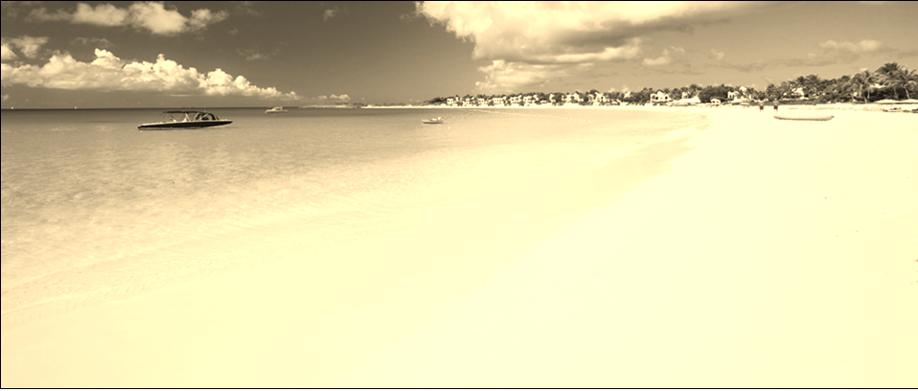

(Sepia filter output)

## 1.4 Discussion

***Resizing:***When you re size an image into a smaller size,you are dropping samples. This would lead to a reduction in quality. In terms of frequency domain, Aliasing might also be one of the problems that will creep in. This would cause issue when you are trying to reconstruct your original image back from the new idea. Ideal way to deal with is to pre-process the image through an spatial anti aliasing filter, so that high frequency components which would cause unwanted effects by aliasing with the smaller frequency component can be removed.

Increasing the size of the image is called up sampling.It involves adding new samples

of value zero in between the samplings of the original image and interpolating these

samples which help of values from its neighbours so that the image is preserved. This

is called bilinear interpolation.

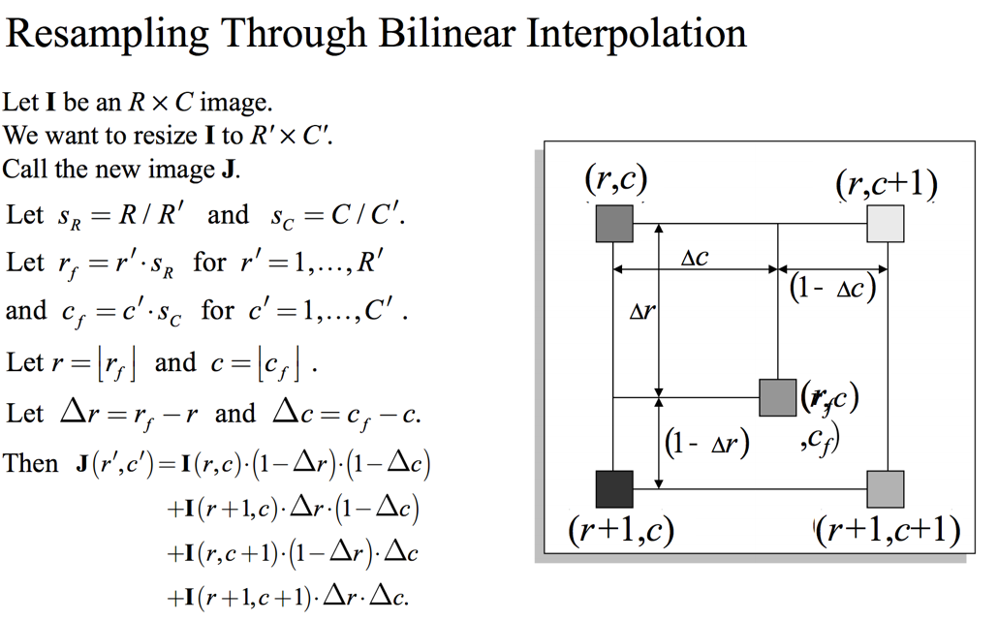(1)

***Reference:Richard Alan Peters' II digital image processing slides on interpolation***

What is at loss here, is the quality of edges. Since we are doing something similar to weighted average with four pixels, we are doing something similar to smoothing and this is obvious in the 600*600 image which appears quite blurred when you compare to 400*400 size image.Literature suggests adaptive algorithms to overcome this.

***Image composting:*** I could imagine clear computer graphics applications when working with this problem. I had ignore the background and merge the dog in the beach image. Problems I ran into while working with the problem is memory and I could not remove the blue background behind the dog completely. This is because the background behind the dog is not completely distributed. Incase I didn’t have memory problem ,I would run Gaussian filter/mean filter along the boundary points so that even though the boundary of the dog might be affected it would make the blue outline go away.

***Colour Transformations:***

CMY gray scale representations of parrot and the building is shown in the images. Unlike the RBG,255 here represents black and 0 represents white.

Grayscale images for H,S and L components are given above. By close investigation, it is seen that each capture different characteristics of the image. The Luminance represents the intensity of the pixel. Higher the luminance value, more brighter the pixel looks. It ranges from 0 to 100% where 0 is black and 100% is white. The Hue represents the colour of the pixel. Intitally when Hue is zero, it captures idea that the that particular pixel in the original image is red. As we increase the hue value, we encounter many other colours.The Hue value ranges from 0-360. Saturation value of the pixel tells you how much the hue component is mixed with white light. When saturation value is dark, it means the original pixel contains white light. We could see saturation value increase as the colour becomes less diluted with the white light. The Saturation value ranges from 0-100% indicative of how much that hue component of the pixel in question is diluted with white light.

***Sepia Filter:***

A gray scale JPEG image approximately takes (5-25%) less space than the colour image.It is evident from colour image size(4.6 MB) which is and black and white image size(1.5MB).

It would be good if we could store as black and white images and try to get RGB values from their gray intensity.Sepia filter gives a yellowish tinge and it is commonly used as special effects in mobile phones.The primary colour intensities are not capured entirely.Interesting fact is One/two of the primary colours entirely in the pixel could be absent but still be given a value by sepia filter when you apply the filter in that pixel. This leaves an idea that sepia does not mostly conserve hue and saturation value of a pixel.

**Layer Blending:**

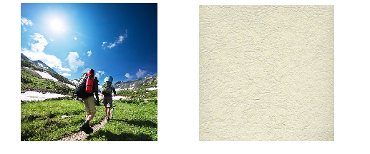

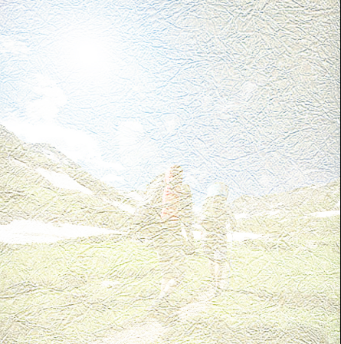 **Screen output**

I used a blending technique called the screen. It is seen that the texture of the bottom layer. The technique gave me the same output even after I interchanged the layers. It has enhanced the second image a lot and it appears as if all the pixel intensity are not equally distributed.

# Problem 2:

# 2.1Abstraction and Motivation:

Did you notice the shadow of the climbers in the above shown Screen blending output image? Were able to appreciate the difference in colour? Similarly in the Saturation output of the Cat can you appreciate its fur colour difference (the fur has some shades of yellow and white). To solve the above mentioned issue and to help to enhance and increase the contrast between pixels Is the reason behind this sections.

There are cases where the pixel intensities get distributed within a short range ,to help in that we have linear transfer function enhancement technique which helps us to spread the pixel intensities apart by mapping the pixel intensity in the original image to a pixel intensity within the desired range spread.

Imagine each intensity value as a bin. Cumulative Probability distribution helps us to distribute the pixels in intensity bins in such a way that all the bins are filled with equal number of pixels. This is one of histogram equalization technique. This also helps to balance the distribution of pixel intensities.

Imagining pixel intensity as a random variable. Histogram Matching is modifying the pdf of the pixel intensity to a pdf like in our case a Gaussian distribution.

## 2.2 Approach and Procedure:

**Method A: A linear Transfer function based histogram enhancement method.**

In some cases,the pixel intensity tend to be confined a particular range of intensities. If a such a case arises and we decide to solve the problem through method A, then the steps to be followed are

1)You plot the histogram of the image.

2)You find F_max and F_min,where F_max is the maximum intensity and F_min is the minimum intensity.

3)You have decide the range you wish to spread the intensities.You have two points (F_min,G_min,F_min) and (F_max,G_max).Find the equation of the line passing through these points.

4)Since we are bounded by range ,we tend to do clipping or take absolute value if the linear function gives us back a value greater than 255 or lesser than zero.

Formula of the Transfer Function:

**Y**=floor(((G_max-G_min)/(F_max-F_min))*(**x**-F_min)+G_min);where x and Y are input and output respectively.

Incase we have three channels, we treat each channel as a separate gray scale image and we do this separately for each channel.

**Method B: The cumulative probability distribution based histogram equalization method**

The method I have implemented is called bucket filling. The basic idea is to read the intensity value of all the pixels and store their location. Then you arrange the pixel by their intensities and you store their location values. Then you basically divide these pixels into 256 bins(starting from 0-255) and start assigning these pixels bin a value from (0-255) .This technique ensures all the intensity bins are equally distributed.

Pixel per bin=#no of pixels/256;

Incase we have three channels, we treat each channel as a separate grey scale image and we do this separately for each channel.

**Histogram Transformation:**

## 2.3 Experimental Results:

Original image:

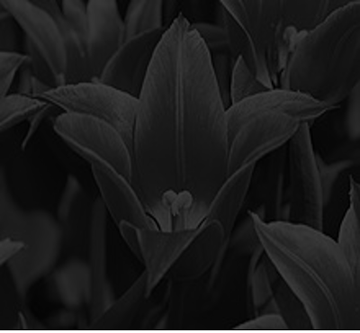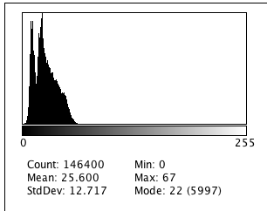

Method A Result:

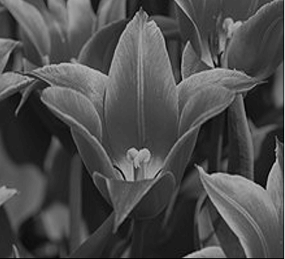 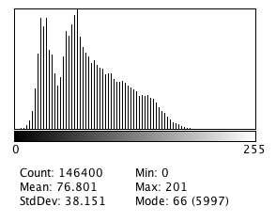

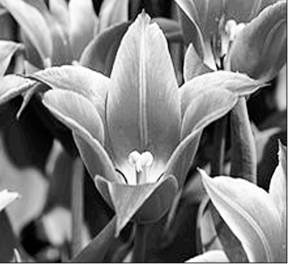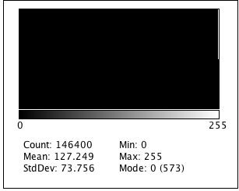

Method B Result

### ***Original Image***

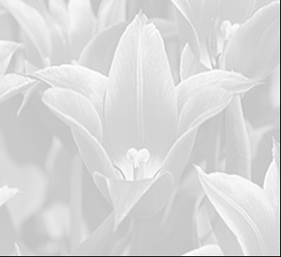 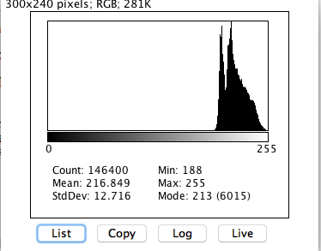

Method A Result:

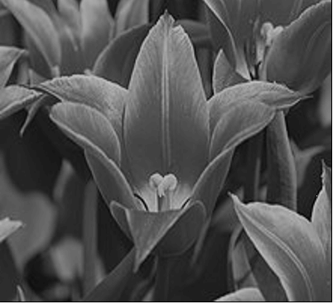 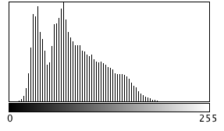

Method B

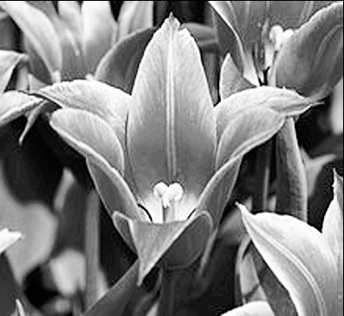 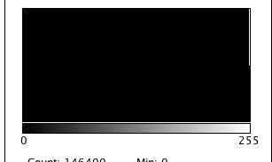

Method A Original Image Method B

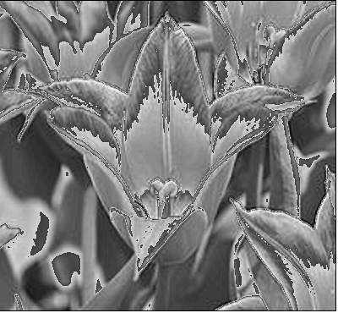 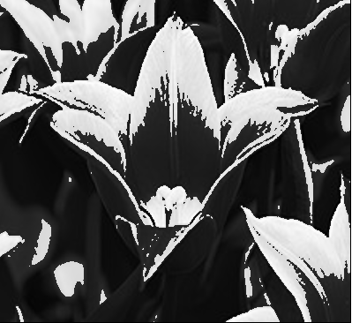 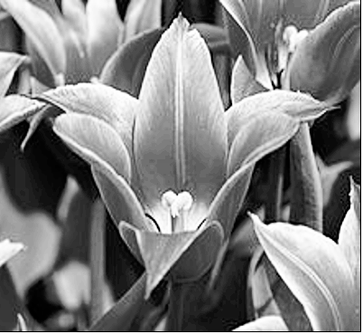

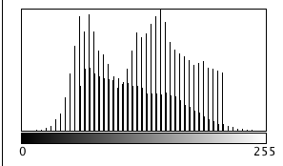 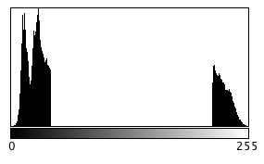 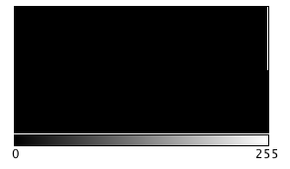

### Applying method A and B to the three channels

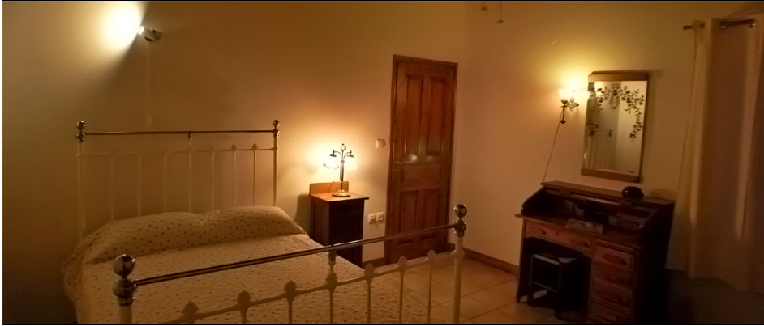

Red channel: Green channel Blue channel

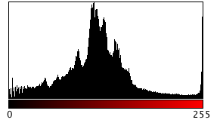 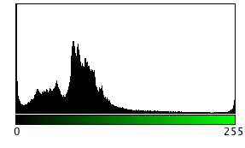 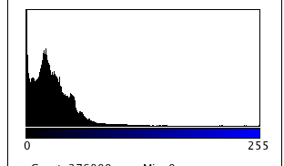

Method B output:

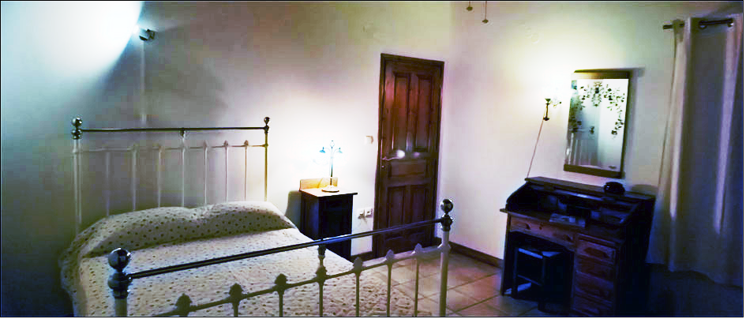

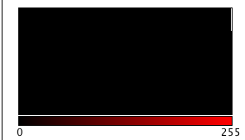 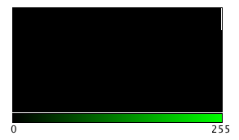 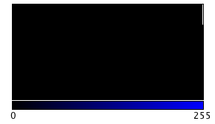

Red channel Green channel Blue channel

Method A:

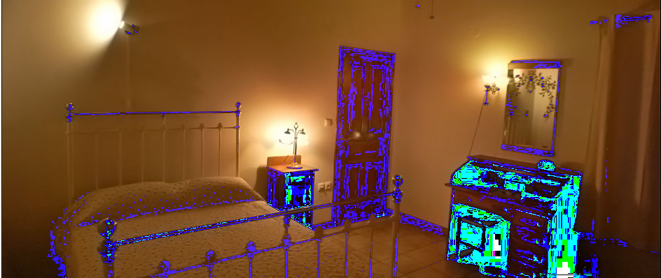

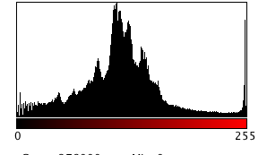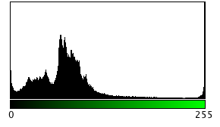 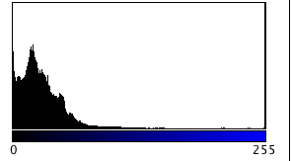

Red channel Green Channel Blue Channel

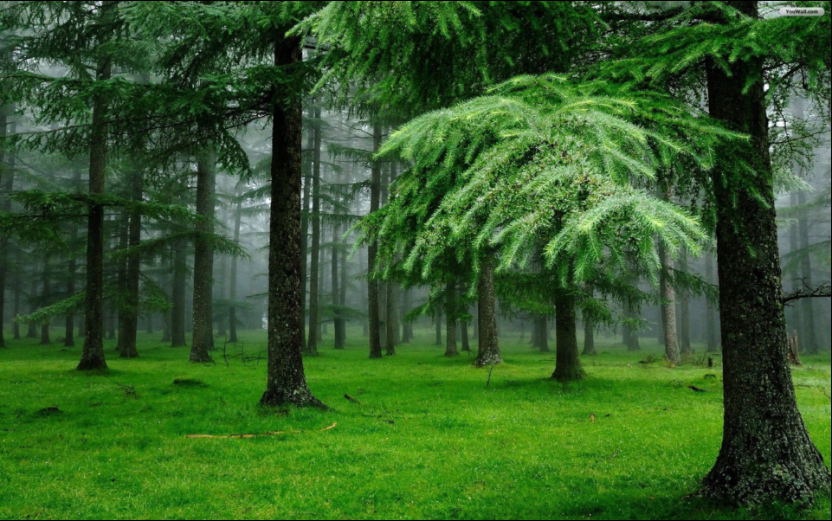

Red channel: GREEN CHANNEL BLUE CHANNEL

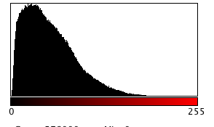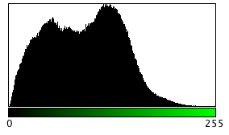 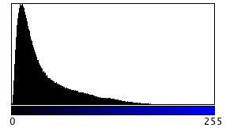

## 2.4 Discussion

The main idea behind Problem 2 is to enhance the contrast in an image and to map the histogram of the intensities in the image to a predefined distribution.

**Analysing the performance of Method A:A linear function based Histogram enhancement method.**

This method is easy to implement and works very well incase the pixels cluster around the low value or cluster around the high value. The issue is when there are two clusters like in the case of tulip_mix the algorithms is trained to detect only the F_min and F_max but it pays no attention to how the pixels are distributed in between the two points .I applied the algorithm twice, one to map one cluster into the range of another cluster and then to map that cluster to 0-255 range. The result is not satisfactory. However the algorithm performs very well with tulip_bright and tulip_dark images,it gives me clean smooth image which gives an idea that low frequencies in the images are preserved. Edges also appear to be preserved to me.

**Analysing the performance of Method B: The cumulative probability based histogram equalization method**

The method performed really well with all the gray scale images. The method does not pay attention to the the distribution of pixel intensity. It arranges the pixels based on their intensity and breaks the array into 256 parts and starts assigning intensity values to the broken parts. The drawback is that the output image appears too sharp, it is almost as if additional edges were introduced .This probably because pixels were assigned value based on their earlier intensity value and hence pixels who were neighbours and had closer values may not have close values anymore after allocation depending on number of bins/pixels between them. This might cause the image to appear sharp after allocation.

Coming to application of Method A and Method B to the colour image, Method A fails to do a good job because the pixels don’t have a range within 0-255,most of the time they are distributed from 0-255.I could choose a range within the range of the distribution, the reason I didn’t do that is because I want to emphasize on the fact the performance of the algorithms becomes a function of a value supplied by the user in addition to the image. The method A fails not only because of its poor performance but also its inability to generalize.

Method B does do the job,but the image looks different. This is because the hue and saturation were not preserved. My proposed method involves converting RGB to HSL model and perform bucketfilling algorithms only on luminance values to preserve the image.

Problem 3:

# 3.1Abstraction and Motivation:

Noise is not new to signals. Noise is introduced by dead sensors, transmission etc.The noise studied here is of two types, Gaussian noise and Salt and Pepper noise.Filters such as mean, median and NLM help us to control these noises. There is a filter window which moves the image and does the filtering operations.

Performance of the filter is measured by PSNR .PSNR Is infinity for a free image. Lower the PSNR, lower the noises in the system.

The idea is that we have a filter window and we perform filtering operations in such a way that every pixel in the input image can occupy the center of the filer window once and the output of the filtering operation would be copied to the co oridnates of the centre pixel.

We extend the Image by floor(window/2) operation and then we run the filter through the image.

## 3.2 Approach and Procedure:

## 3.2.1 Mean and Median Filter

Mean and median are simple filters. As discussed before the mean/median filtering runs across this extended image such a way that every pixel in the image(before extention)would be at the center of the window. Mean calculates the mean of all the elements in the window and places it at the coordinates of the center pixel in the output window.

Median calculates the median of all the numbers in the filter window and places it at the coordinates of the center pixel in the output window.

Mean is a linear filter. Gaussian filter can be viewed as weighted mean filter. They are commonly used to address Gaussian noise, salt and pepper noise.

Median is a non linear filter.

### 3.2.2 NLM filter

NLM is a powerful renoising tool.This has three important parameters,window size,search window size and sigma value.Value of the pixel is calculated by averaging the values of the similar pixels.This helps us in reducing the random noise associated with the pixel of interest.

The blockmatching 3D filter was studied using the paper mentioned.The sigma values were varied for both the images and psnr is mentioned below.

# 3.3 Experimental results:

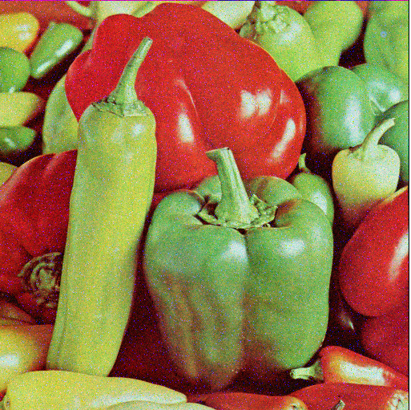

ORIGINAL NOSIY IMAGE

Red GREEN BLUE

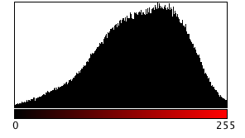 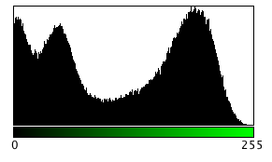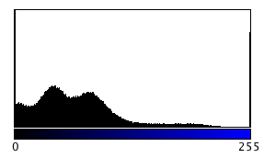

After applying mean filter(Filter size=5)

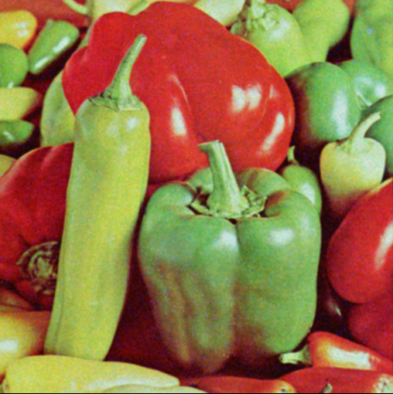

After applying median (filter size=5)

After applying NLM (Window size =7)

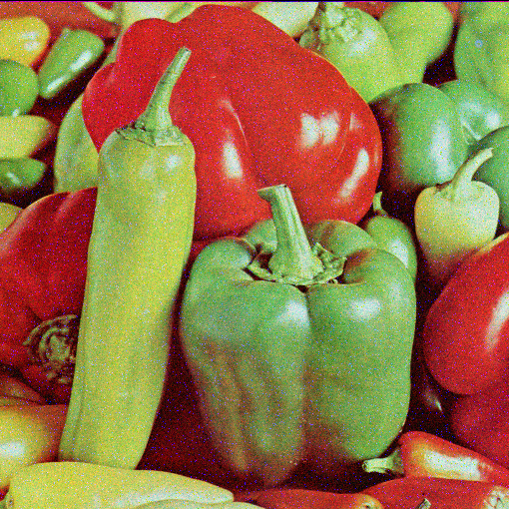

Applying Mean after applying median filter(size=5)

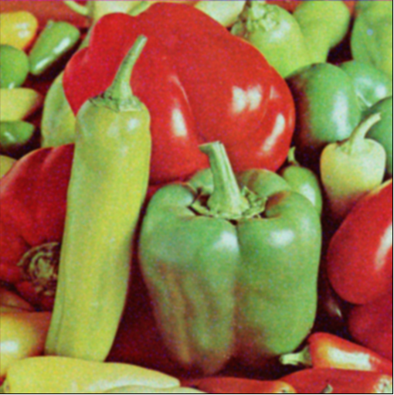

### BM3D

Original image BM3D (SIGMA =50)

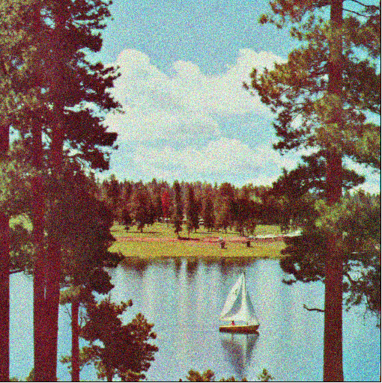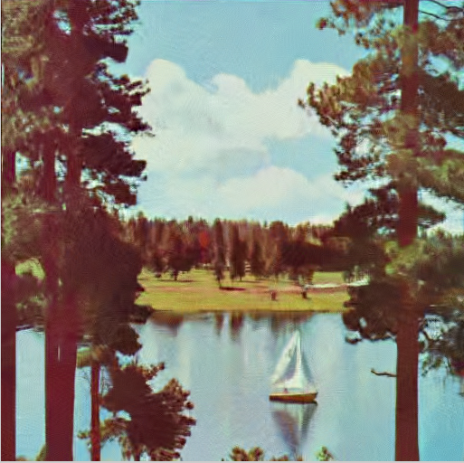

PSNR: 22.63 dB

BM3D(SIGMA=10) BM3D(SIGMA=30)

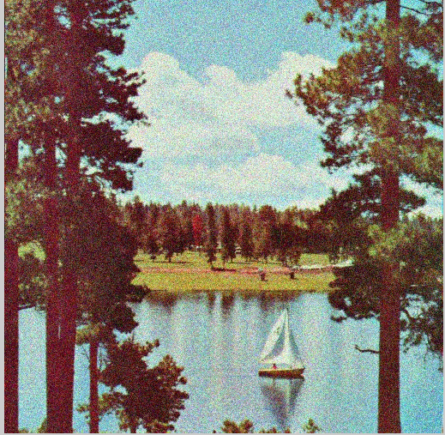 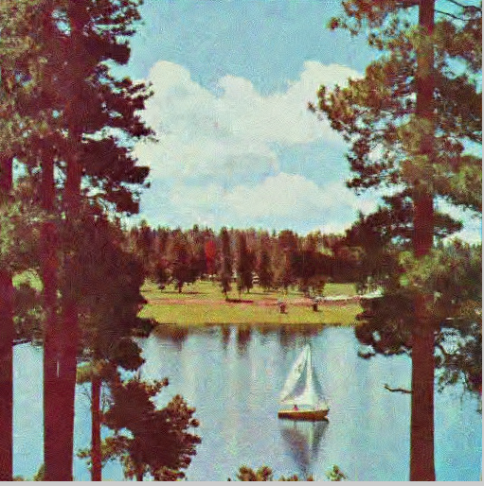

PSNR :31.66 dB PSNR= 22.6269

The effect of sigma on PSNR is almost negligible after sigma becomes greater than 30 for the sailboat image.

 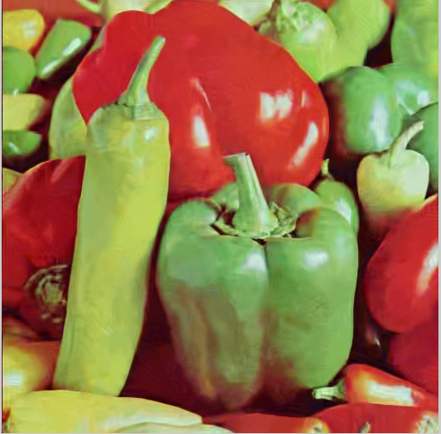

Original Image BM3D(sigma=50) PSNR: 24.88 dB

BM3d(sigma=30)( PSNR: 26.01 dB)

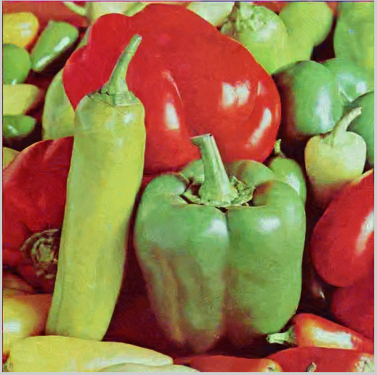

Discussion:

It is seen that not all the channel have the same noise.It is seen from their histogram that they all suffer from mixture of different noises.

It is better if we perform individual filtering on each channel.I would like to use median and mean filter to tackle this noise.

Median followed by mean gave me a good output.

Median followed by mean gave me a better output. Shortcomings of these filter are that they are local and it does not consider similar pixels far away in their algorithms.If the image is not big,I would suggest going for NLM.

NLM takes random noise,it helps to preserve the structure of the image while taking care of the random noise. Drawback of NLM is its computational complexity.

In BM3D,we find similar patches in the 2D image. Group Similar patches together and arrange it as 3D block. This involves spatial transformation.----(1)

Block undergoes linear transformation, in this domain the operations are performed and then then we do reverse linear transformation followed by Weiner Filtering.—(2)

Wiener Filter removes noises including the ones which were added because we moved from 2d space to 3d space. Then we come back to the 2d space .Since this might not be a one to one mapping ,in case two pixels in the 3d block are assigned to same pixel, we perform averaging operation.

It performs both spatial and frequency operations. Hence it is a filter operating in both the domains.

***Reference:***

***1)Richard Alan Peters' II digital image processing slides on interpolation***